57th Annual NAEPC
Advanced Estate Planning Strategies
Virtual Conference

November 10, 2020 ∙ 11:30 am ET - 5:00 pm ET

12:25 pm ET | 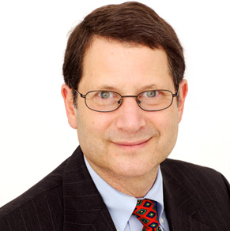"Estate Planning in Light of the Election Results"  Martin M. Shenkman, CPA/PFS, MBA, JD, AEP® (Distinguished)  This presentation will address potential considerations for various election outcomes, including a Republican victory,  Democratic Victory but Republican Senate, or a Democratic sweep… select just one, as it will be multiple choice!
1:25 pm ET | Networking Break & Exhibit Hall Open
1:55 pm ET | 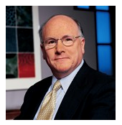"Are You in Good Hands?"  Richard M. Weber, MBA, CLU®, AEP® (Distinguished)  This session will offer an exploration of suitability and client best interest in the sale and purchase of life insurance.  Attendees will be among the first to learn of the regulatory movement substantially increasing the standard of care  owed to buyers of life insurance. While mainly affecting licensed agents and CERTIFIED FINANCIAL PLANNER™  designees, non-licensed allied professionals will likely be caught unaware of these regulatory changes. Attendees  will learn: a description of enhanced regulations currently in effect in various states; information about comparable  changes in the fiduciary obligations of CERTIFIED FINANCIAL PLANNER™ designees to their clients; practical  tools that currently exist to meet these requirements - fulfilling both the letter and spirit of the new requirements;  how many new life insurance products defy the consumer’s (and agent’s) ability to determine the amount of risk  the client takes to achieve an expected reward; and how allied professionals will likely want to interact with their  clients going forward.
2:55 pm ET | Networking Break & Exhibit Hall Open
3:15 pm ET | 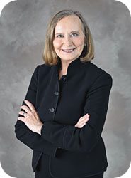"The Ins and Outs of QCDs"  Natalie B. Choate, Esq., AEP® (Distinguished)  Qualified charitable distributions are a popular tax saving device for all IRA owners over 70.5 - helping the  "little guy" as well as the rich and famous. They're easy, they're simple, and people still mess them up.  During her presentation, Natalie Choate will offer 12 things you didn't know about QCDs.
4:15 pm ET | Closing Remarks
4:20 pm ET | Networking Reception & Exhibit Hall Open
30-Minute Sponsor Bonus Sessions (two choices)
Option #1: Oil & Gas Assets – Fiduciary Risk Mitigation and Regulatory Issues​
Wes Turiano
session brought to you by Farmers National Company Oil & Gas Management
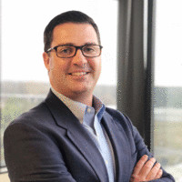This session will describe how Fiduciaries can manage risk associated with management of oil & gas assets held in trust, through prudent and pro-active management. The presentation
will include three key elements of a successful oil & gas management program: a) planning for oil & gas ownership
(due diligence, pre-acceptance evaluations, market valuations); b) management of oil & gas assets
(revenue accounting, land administration, revenue maximization, leasing); and c) risk issues associated
with oil & gas assets (title curative, lease values, dormant mineral filings, working interest review).
Option #2: Positioning Your Business for Growth
Mike Thurman
session brought to you by White Glove
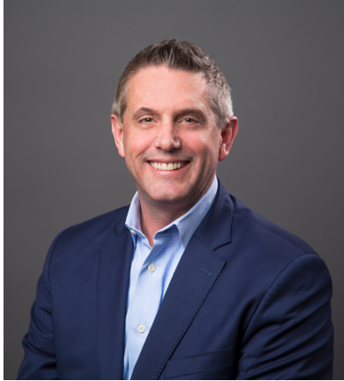The current pandemic has forced everyone to alter, or in some circumstances, completely halt their marketing efforts this year. However, now more than ever, clients are seeking professionals
to provide much needed education and estate planning assistance. Join this session to discuss real results the sponsoring firm has seen in the industry and what new methods have helped financial professionals partner with estate planners to position their business for growth.
5:00 pm ET | Conference Concludes

